EXPERIMENT 21: TIC-TAC-TOE GAME
AIM
To write a Python program to implement a Tic-Tac-Toe game for two players.
ALGORITHM
- Start the program.
- Initialize a 3 × 3 game board.
- Display the board.
- Ask the current player to enter a position.
- Check whether the position is empty and make the move.
- Check for a winner or a draw.
- Repeat until the game ends.
- Stop the program.
CODE
board = [" "] * 9
def display():
for i in range(0, 9, 3):
print(board[i], "|", board[i+1], "|", board[i+2])
if i < 6:
print("--+---+--")
def check_winner():
wins = [
(0, 1, 2), (3, 4, 5), (6, 7, 8),
(0, 3, 6), (1, 4, 7), (2, 5, 8),
(0, 4, 8), (2, 4, 6)
]
for a, b, c in wins:
if board[a] == board[b] == board[c] != " ":
return board[a]
return None
player = "X"
turns = 0
while turns < 9:
display()
pos = int(input(
f"Player {player}, enter position (1-9): "
)) - 1
if pos < 0 or pos > 8 or board[pos] != " ":
print("Invalid position! Try again.")
continue
board[pos] = player
turns += 1
if check_winner():
display()
print("Player", player, "wins!")
break
player = "O" if player == "X" else "X"
else:
display()
print("It's a draw!")
OUTPUT
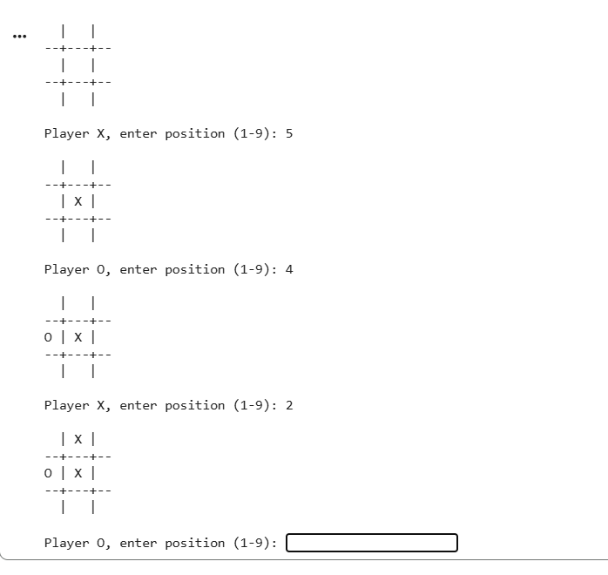
RESULT
Thus, the Python program to implement a Tic-Tac-Toe game was executed successfully.

EXPERIMENT 22: MINIMAX ALGORITHM FOR GAMING
AIM
To write a Python program to implement the Minimax algorithm for decision-making in games.
ALGORITHM
- Start the program.
- Define the game tree with leaf values.
- Evaluate the leaf nodes.
- Find the maximum value at maximizing nodes.
- Find the minimum value at minimizing nodes.
- Display the best value.
- Stop the program.
CODE
def minimax(tree, maximizing):
if isinstance(tree, int):
return tree

values = [
minimax(child, not maximizing)
for child in tree
]

if maximizing:
return max(values)
else:
return min(values)

game_tree = [
[3, 5],
[2, 9],
[0, 1]
]

best_value = minimax(game_tree, True)

print("Best value:", best_value)
OUTPUT
Best value: 3
RESULT
Thus, the Python program to implement the Minimax algorithm was executed successfully.

EXPERIMENT 23: ALPHA-BETA PRUNING ALGORITHM
AIM
To write a Python program to implement the Alpha-Beta Pruning algorithm for gaming.
ALGORITHM
- Start the program.
- Initialize alpha to negative infinity and beta to positive infinity.
- Evaluate the game tree recursively.
- Update alpha at maximizing nodes.
- Update beta at minimizing nodes.
- Prune a branch when alpha is greater than or equal to beta.
- Display the optimal value.
- Stop the program.
CODE
def alpha_beta(tree, alpha, beta, maximizing):
if isinstance(tree, int):
return tree

if maximizing:
value = float('-inf')

for child in tree:
value = max(
value,
alpha_beta(child, alpha, beta, False)
)

alpha = max(alpha, value)

if alpha >= beta:
break

return value

else:
value = float('inf')

for child in tree:
value = min(
value,
alpha_beta(child, alpha, beta, True)
)

beta = min(beta, value)

if alpha >= beta:
break

return value

game_tree = [
[3, 5],
[2, 9],
[0, 1]
]

result = alpha_beta(
game_tree,
float('-inf'),
float('inf'),
True
)
print("Optimal value:", result)
OUTPUT
Optimal value: 3
RESULT
Thus, the Python program to implement Alpha-Beta Pruning was executed successfully.

EXPERIMENT 24: DECISION TREE
AIM
To write a Python program to implement a Decision Tree classification algorithm using machine learning.
ALGORITHM
- Start the program.
- Import the required libraries.
- Define the input dataset and target labels.
- Create a Decision Tree classifier.
- Train the classifier using the dataset.
- Predict the class of a new input.
- Display the prediction and accuracy.
- Stop the program.
CODE
from sklearn.tree import DecisionTreeClassifier
from sklearn.metrics import accuracy_score

# Input: Study hours and attendance percentage
X = [
[1, 40],
[2, 50],
[3, 60],
[4, 70],
[5, 80],
[6, 90]
]

# 0 = Fail, 1 = Pass
y = [0, 0, 0, 1, 1, 1]

model = DecisionTreeClassifier(random_state=0)
model.fit(X, y)

predictions = model.predict(X)

print("Predictions:", predictions)
print("Accuracy:", accuracy_score(y, predictions))

new_student = [[5, 85]]
result = model.predict(new_student)

if result[0] == 1:
print("Prediction: Pass")
else:
print("Prediction: Fail")
OUTPUT
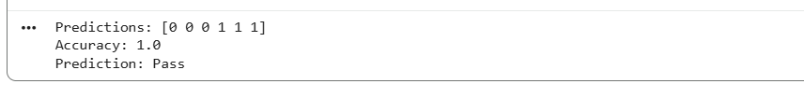RESULT
Thus, the Python program to implement Decision Tree classification was executed successfully.

EXPERIMENT 25: FEED FORWARD NEURAL NETWORK
AIM
To write a Python program to implement a Feed Forward Neural Network for the XOR problem.
ALGORITHM
- Start the program.
- Import NumPy and the required machine learning library.
- Define the input data and target outputs.
- Create a neural network with an input layer, hidden layer and output layer.
- Train the network using the input data.
- Predict the output for the given inputs.
- Display the predicted outputs.
- Stop the program.
CODE
import numpy as np
from sklearn.neural_network import MLPClassifier

# Input data for the XOR problem
X = np.array([
[0, 0],
[0, 1],
[1, 0],
[1, 1]
])

y = np.array([0, 1, 1, 0])

# Create the feed forward neural network
model = MLPClassifier(
hidden_layer_sizes=(8,),
activation='tanh',
solver='lbfgs',
max_iter=5000,
random_state=1
)

# Train the network
model.fit(X, y)

# Predict output
predictions = model.predict(X)

print("Input:")
print(X)

print("Predicted Output:")
print(predictions)
OUTPUT
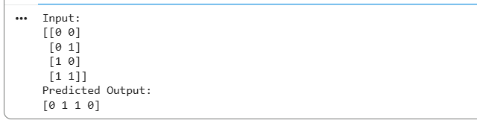
RESULT
Thus, the Python program to implement a Feed Forward Neural Network for the XOR problem was executed successfully.

